|  |  |
| --- | --- |
| Dahlonega logo | **Department Report** |

|  |  |
| --- | --- |
| Report Title: | Public Works—July 2024 |
| Name and Title: | Mark Buchanan, PW Director/City Engineer |
| Recently Completed: | |

* Installation of sycamore Bear on the Square carving. Construction of brickwork and installation of coping was going on at the time of this writing.

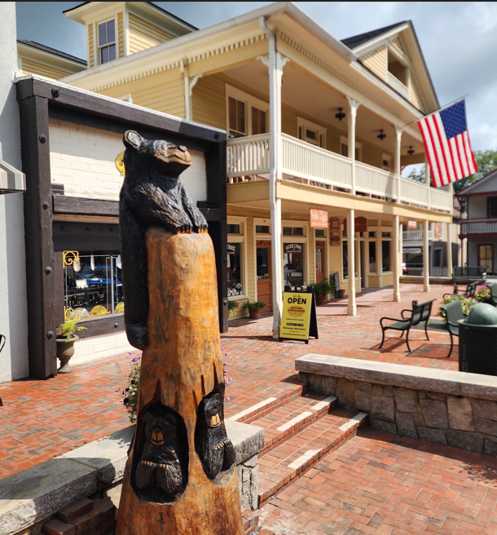 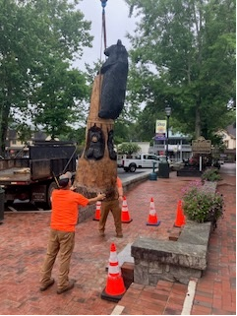

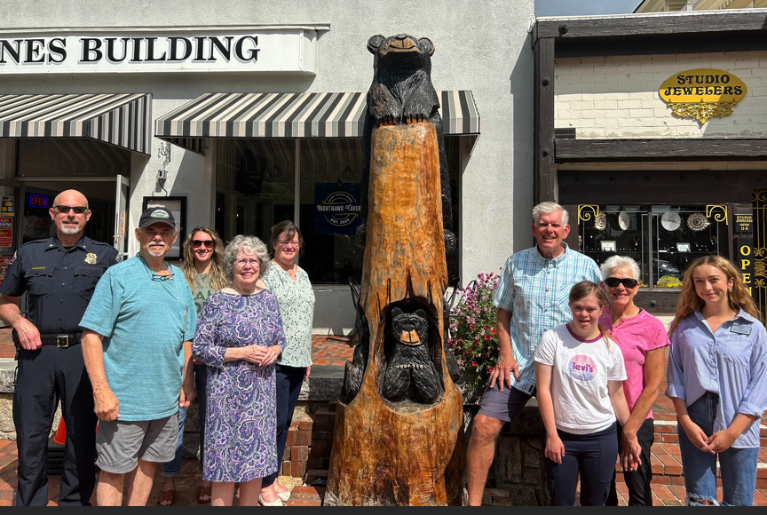

* Reconstruction of one block of sidewalk along Church Street. More is planned in the coming year.

* Significant roadside clearing of Wimpy Mill Road. This was a weeklong project that made extensive use of the city’s new Genie Lift.
* Installation of a more robust speed bump on Happy Hollow Road. Earlier paving had rendered the previous speed hump mostly ineffective. The City is testing this much more cost effective technique as opposed to complete demolition and asphalt reconstruction.

* Shoulder reconstruction and stormwater management performed by City crews on Trahlyta Trail. This project required cooperation with multiple landowners and City staff.

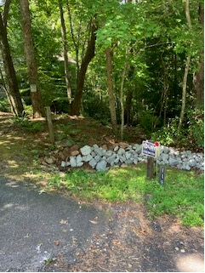 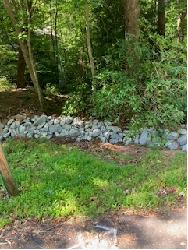

Ongoing:

* Continual improvements to Conner Garden.

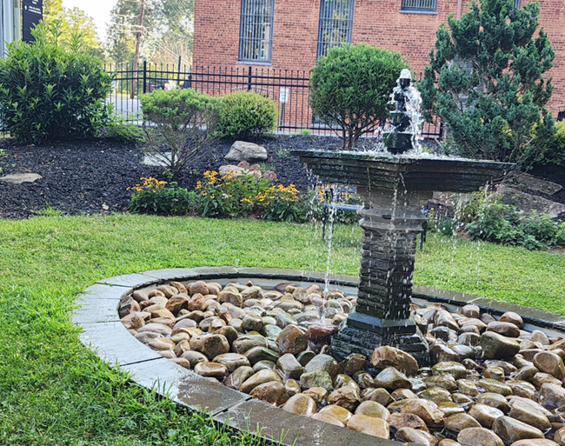

* Sewer and sidewalk repairs and construction near the Visitors’ Center.

* Morrison Moore Pedestrian Bridge and Sidewalk design and permitting. At this time, construction is expected in late 2024.
* Golden Avenue storm drain. Coordination with neighboring property owners regarding necessary easements is ongoing. Georgia DOT is conducting the preliminary design of the Yahoola bridge near this location. Staff are also coordinating with them to ensure a seamless transition between these two neighboring projects.
* Design and bid services for Phase 2 of the North Grove sidewalk project from Subway to Skyline Drive. Plans are currently under review by GDOT.
* Revegetation of the Hancock Park yard. This is becoming more challenging each year as the event season continues to expand not only to cover roughly 10 months of the year, but also to draw more and more foot traffic. The combination of heavy foot traffic, minimal to moderate sunlight and desire for a “cold-weather” grass (i.e. a grass that stays green year round) requires constant maintenance with varying results.
* Park Street Utilities Project is underway.

Upcoming (these projects are currently either in concept, design or construction phase):

* Selected portions of the Arcadia Street water and sewer main project/Mechanic Street to Morrison Moore sidewalk.
* Visitors’ Center Plaza surface replacement and sanitary sewer repair.